Artificial Neural Networks
Lab Report #8

Sharrena Mae B. Camus (11227427)  shane_camus@yahoo.com | John Elijah B. Santos (11224436)  jebssantos@gmail.com
Angelica Grace D. Terrado(11235322)
angelica_terrado@dlsu.edu.ph

- ABSTRACT
Using Ipython in Jupyter Notebook instead of Octave, machine intelligence Lab6 introduces Neural Network on an interactive implementation of logistic regression from data and architecture to numerical gradient checking.

Keywords – Ipython Notebook, Neural Network, Python, Logistic Regression
- INTRODUCTION
According to Stergiou and Siganos, Neural Networks are entities that are programmed in such a way that would emulate the functions of the network of neurons that preside in the biological nervous system of the brain. These neurons take information as inputs and put them through certain processes, linking one neuron to the other in order to come-up with the desied output. The interconnection of these neurons is vital to the entire process hence the term neural networks. This is usualy done to solve a problem that involves predicting, which requires the machine to initially learn the ropes. Rather than having the programmer tell the machine exactly what to do and when, conditions and such, the machine learns by itself given only the data and certain algorithms such as regression in order to form intellectual hypotheses reliable enough to provide means to prediction. The advantages of using neural networks rather than manual and conventional coding include the ability of the network to adapt to different kinds of data, organize itself based on the information, real-time operation, and its determined tolerance to errors.

- OBJECTIVES
- To be able to implement a simple Neural Network at least up to Numerical Gradient Checking using Ipython Notebook.
- To be more familiarized with the interactive computing Iphyton in Jupyter Notebook environment.
- DATA AND RESULTS
After scaling or standardizing data and implementing forward propagation using numpy's built in dot method for matrix multiplication from the first two parts of the experiment, bad predictions were produced and the task now is to make these predictions better. The first step made in part 3 was to compare the values of y and yhat.

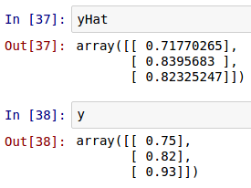
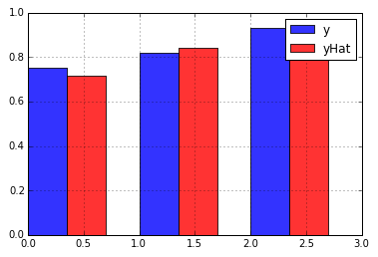

It is expected that y and yHat aren't the same but from this particular result, yHat is relatively accurate. However, we can still improve this Neural Network model by minimizing the cost function aka traning the network. According to Stephen, our only control of our data is finding the best possible weight to minimize the cost function. So when a set of values of weights were tested, the time elapsed of my computer were as follows:

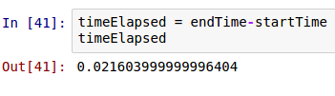
0.02 seconds is not so bad and from this step we can assume that one part of network is succesfully trained. This can also be seen at the Cost vs. Weigh graph shown below.

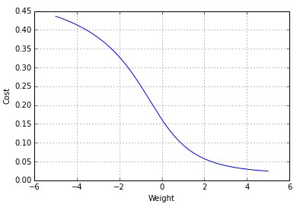
However, what if we continue to optimize the network by finding another best possible weight, making them two? Well, the effect to the time elapsed for the computer to find the value is tremendous having checked one million values for the best possible weights. Stephen calls this the Curse of Dimensionality.

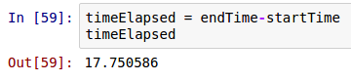

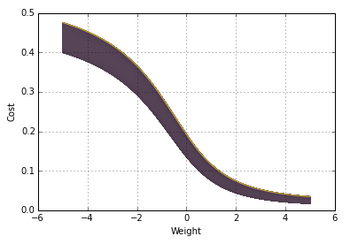

Now even though we can leave it at that and simply use brute force to find the best value for weight having the least cost value, we shouldn't be just satisfied with that and consider finding other methods. This is were gradient descent comes in, where the partial derivative of the cost function can be used to speed things up and immediately find the best weight value. The only idea behind this is that instead of spending time finding the value in the wrong direction, we program the computer to immediately find where the graph goes downhill, ultimately finding the minimum point of the graph.

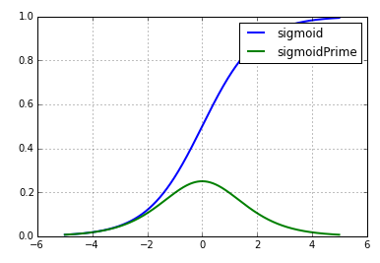

Stephen discussed next that not only do we need to get the partial derivative of the cost function, we also have to get the derivative of the sigmoid function with respect to z. With all of these, the Neural Network model is updated to the code shown below:

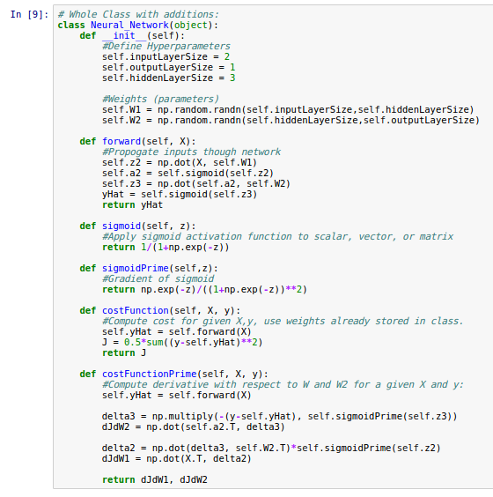

Notice that there are two computed derivative functions named sigmoidPrime and costFunctionPrime.
With the updated version of the NN model, we can most probably now find values of our weights for us to decrease the error or cost. Applying the core algorithm of gradient descent, the following cost values are produced.

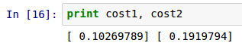
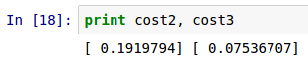

It is quite obvious that even though we were able to get values of the cost function from the optimized value of weights, we don't have any means of checking if the math done is correct or wrong. So with this, a numerical gradient checking is needed to be implemented.

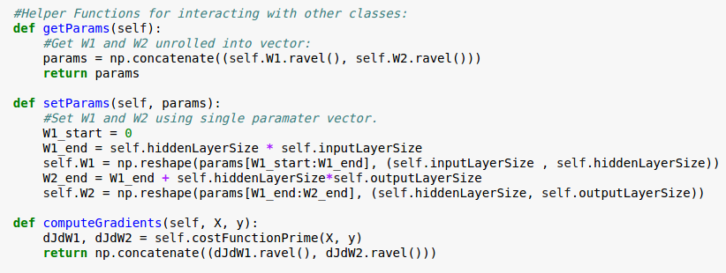

The helper functions shown above is added to the Neural Network Model. This functions are added to help us evaluate the gradient of our model. It is imporant to remember also that we are not only working on 1 gradient value but rather 9 so it is required to test each of them. Another piece of code is needed for us to produce a numerical gradient vector. This vector needs to be compared to our original gradient calculation to determine if we have computed the gradient correctly.

It is safe to assume that the gradient values are almost similar, but we still have to make sure, and so, the computation below is done and then we can say that our computation is correct if the output is less than the usual 10^-8

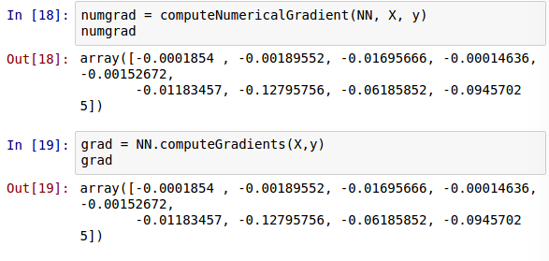

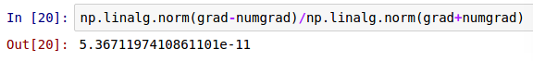

- ANALYSIS AND CONCLUSION

This lab experiment does not completely implement the proper and complete training of an artificial neural network yet since we are still lacking with the training of the neural network itself and the concept of avoiding overfitting, implementing testing and regularization. However, we can conclude at this stage that it has the huge advantage compared to applying just the simple logistic regression. If we have understood correctly, Neural Networks include the optimization of the processes within the process since we give the computer the go signal to learn from itself and to be able to produce a more accurate prediction of any application. A set of data allows the neural network to produce a needed predicted output without much help from the programmer. This model has been used for some time now and it can be concluded that neural networks is a phenomenal tool that can perform highly complex decision boundaries for thousands of applications.

[1] Neural Networks by Christos Stergiou and Dimitrios Siganos (http://www.doc.ic.ac.uk/~nd/surprise_96/journal/vol4/cs11/report.html)

